Progress Report – PCI system

Rakshit Singh – FCS113

Avnit Sharma – FCS041

Project Description

The software to be designed is an open source online Personal Counseling Interaction system for an institute that will be deployed on the web, so as to ease/speedup the admission process (PCI). This software will create a video communication channel through which the faculty (interviewer) will be able to assess the student/applicant (interviewee) and shortlist him for admission to the institute.

Goals

The software/system should have the following features/properties:

* Developed for the web (internet), i.e. a Web App.
* Be cross compatible i.e. compatible across multiple browsers.
* Be open source.
* Have a GUI (graphical user interface) that is user friendly.
* Connection to the client (applicant) should be via a hyper-link that the server (interviewer) provides.
* Must be safe and secure.
* Options for one to one and group conference.
* Questionnaires fill up option.
* Document Sharing mechanism.
* Chat Box.

Current Scenario

* Selected WebRTC as the platform.
* Selected GoogleDrive for data storage.
* Selected Google Forms for questionnaire.
* Started testing the above mentioned.

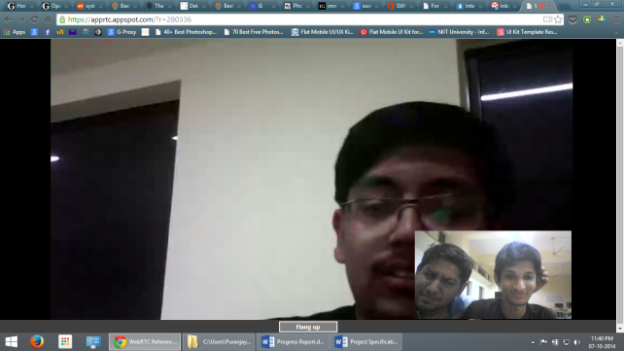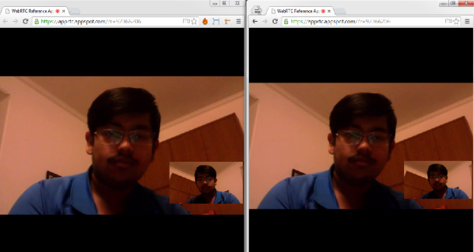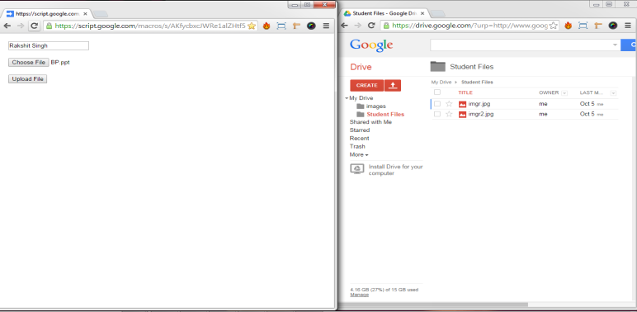

Time line

Phase 1 (completed)

Requirements – Gathered requirements from customer.

Research – Looked for best available technologies and platforms to support our cause. Finally, narrowed down to WebRTC and GoogleDrive.

Design-Crude Prototyping – Basic video conferencing app and basic file uploading to google drive mechanism.

Phase 2 (ongoing ) //most time consuming and critical phase

Implementing phase – Coding and designing the functionalities, modules and developing the GUI.

Finalizing the requirements phase i.e. the prototyping and moving towards stability, testing and maintainability of the project.

Phase 3 (tentatively will be done by end of november)

Testing phase – Testing the project for all bugs and errors.

Hosting project on github and providing 3rd party support.

Phase 4

Finally publishing the project and hopefully getting a good grade.

Maintaining the project via github.

Current position:-

We are currently in middle of phase 2 of our project, we are running a little behind of our planned time line, as we had planned that we would have be in final steps of phase 2, but due to some issues we were stuck for some time (signaling server issues...will discuss in person if necessary) but now we have been able to figure it out by ourselves, because its my belief that best learning happens when you search for the answers yourself.

We have some components such as file/document uploading , video calling and room creation almost in the finishing stages but we still are working on components such as recording,screen sharing and chat box.

Our design is ready on paper but yet to be discussed with the project advisor .We would be talking to him in the next couple of days and if we get his approval then we will surely be able to finish phase 3 in November only.

Hopefully we will be able to sort out our issues quickly and would have started the next phase by mid November, giving us adequate time for testing and making changes.